# **Database Design for Costco Corporation**

# **Introduction**

Established in 1976, Costco Wholesale Corporation is one of the world's largest retailers, operating through a warehouse club model. Costco offers a wide range of products to its multitude of members, including groceries, household items, electronics, and luxury goods, all at competitive prices. As a membership-driven model, Costco places significant emphasis on operational efficiency, cost-effectiveness, and customer satisfaction. The following is a case study that focuses on designing a database structure for Costco to efficiently manage inventory, sales history, and membership information for its members.

The case study includes:

* A database architecture to enhance Costco’s operations.
* Key tables and relationships within the database.
* Queries and entity-relationship diagrams for better visualization.

# **Mission**

Costco is dedicated to consistently providing its members with high-quality goods and services at the lowest prices possible. The goal of the Costco database design is to create a system that enhances operational efficiency to improve customer satisfaction and maintain membership through strong data integrity and scalable performance.

# **Objectives**

**1. Efficient Supply Chain Management:** Improve the efficiency of procurement processes and supply chains by better tracking and managing data.

**2. Seamless Customer Experience:** Ensure product availability, accurate pricing, and smooth inventory control to enhance customer satisfaction.

**3. Cost-Effective Operations:** Provide operations at the lowest possible cost to support Costco's competitive pricing model.

**4. Improved Membership Retention:** Track member patterns and preferences to offer more personalized service and improve membership retention.

**5. Scalable Database Architecture:** The database architecture is highly scalable, supporting business growth in the future and accommodating any operational changes.

# **Database Structure**

## **List of Tables and Key Fields**

1. **Members Table:**

**Fields:** MemberID (Primary Key), FirstName, LastName, Email, PhoneNumber, Address, MembershipType.

1. **Products Table:**

**Fields:** ProductID (Primary Key), ProductName, Description, Price, QuantityInStock, CategoryID (Foreign Key), SupplierID (Foreign Key).

1. **Orders Table:**

**Fields:** OrderID (Primary Key), MemberID (Foreign Key), OrderDate, TotalAmount, Status.

1. **Suppliers Table:**

**Fields:** SupplierID (Primary Key), SupplierName, ContactPerson, Email, PhoneNumber, Address.

1. **Inventory Table:**

**Fields:** InventoryID (Primary Key), ProductID (Foreign Key), WarehouseID (Foreign Key), QuantityAvailable, LastRestockedDate.

1. **Transactions Table:**

**Fields:** TransactionID (Primary Key), OrderID (Foreign Key), TransactionDate, PaymentMethod, AmountPaid.

1. **Warehouses Table:**

**Fields:** WarehouseID (Primary Key), ManagerID (Foreign Key), Location, Capacity, PhoneNumber.

1. **Employees Table:**

**Fields:** EmployeeID (Primary Key), FirstName, LastName, Email, Department, Position, HireDate, ManagerID.

1. **Categories Table:**

**Fields:** CategoryID (Primary Key), CategoryName, Description.

1. **OrderDetails Table:**

**Fields:** OrderID (Primary Key, Foreign Key), ProductID (Primary Key, Foreign Key), Quantity, PriceAtOrder.

## **Entity Relationship Diagram (ERD)**

The ERD showcases the relationships between the various tables. Key relationships include:

* **One-to-Many:**
  + A single member can place multiple orders.
  + One supplier can provide multiple products.
  + Products belong to categories and are stored in warehouses.
* **Many-to-Many:**
  + Products and orders have a many-to-many relationship, which is managed through the OrderDetails table.
* **One-to-One:**
  + Each warehouse is managed by a single employee (Warehouse Manager).

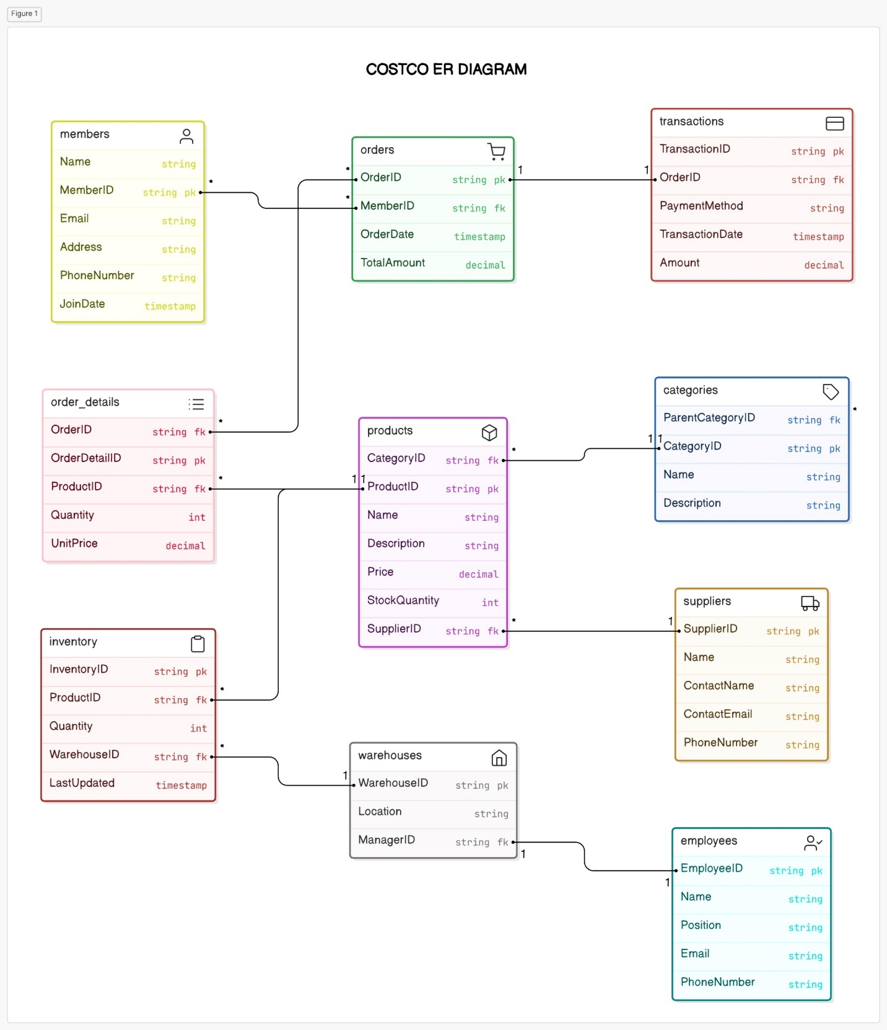

## **Queries**

Several SQL queries were developed to demonstrate interactions with the database:

* **Join Queries:** Connect the Members, Orders, Products, and Transactions tables.

* **Views:** Simplify complex queries for reporting purposes.

# **Conclusion**

The database design outlined in this case study is essential for Costco's operational efficiency and long-term growth. It captures crucial aspects of Costco's business, such as member information, product inventory, supplier management, and order processing, supporting seamless interactions across all departments.

By establishing well-defined relationships between tables, including one-to-many, many-to-many, and one-to-one relationships, the system ensures efficient data management and scalability. This robust architecture allows Costco to streamline operations, optimize inventory control, and maintain high customer satisfaction, all while keeping operational costs low as the company continues to grow.

Overall, this design not only improves Costco's ability to meet current demands but also prepares the company for future expansion, ensuring sustained success in a competitive retail environment.